**Exercise no:1**

**Register no:**1518102710

**Date:**17.10.2020

**Aim:**

To print the calendar of a given month and year.

**Program:**

import calendar

year=int(input())

month=int(input())

if(year<10000 and year>999 and month < 13 and month>0):

print(calendar.month(year,month))

else:

print("invalid input")

**Link:**

<http://103.53.53.18/mod/vpl/forms/edit.php?id=229&userid=1713>

**Output:**

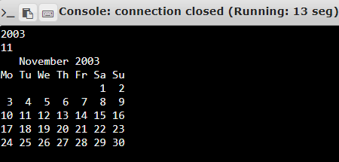

**Result:**

Thus the code has been successfully executed and output is verified.